Software Engineering – Lab 1 Report
Huynh Nhat Huy – 523c0012
Software Engineering (2025 – 2026) - TDTU

Exericses 1 - 10

Following instructions in 10 exercises, I developed a fundemental understanding of building GUIs using WinForms (C#).

In Exercises 1 – 3: I learnt how to create a WinForms project and utilize the Toolbox to design a GUI by adding elements by Label, Button and TextBox. Also, I learnt the basics of event-driven programming by writing event handlers, such as updating a label’s text and triggering a MessageBox when a button is clicked.

In Exercises 4 - 5: I learnt how to build a simple calculator by learning how to retrieve input from multiple textboxes controls, perform basic arithmetic operations (+ - * /), and dynamically update the UI to display the calculated result,

I also learnt how to populate listboxes and comboboxes with items programmatically during the form’s Load event. I also learned how to retrieve and display the user’s selected item.

In Exercises 6 – 9: I learnt how to use the DataGridView control for displaying tabular data. I learned how to define columns and populate the grid with sample data arrays and adding new rows at runtime using user input, and how to enable row editing and deletion. I also learned how to integrate a ComboBox column directly within the DataGridView for flexible data entry.

In Exercise 10: I learnt how to use the DateTimePicker and ProgressBar controls. I learned how to use a Timer to simulate a background process, using code to incrementally update the ProgressBar’s value at set intervals until completion.

Exercises 11-20 Summary Report

11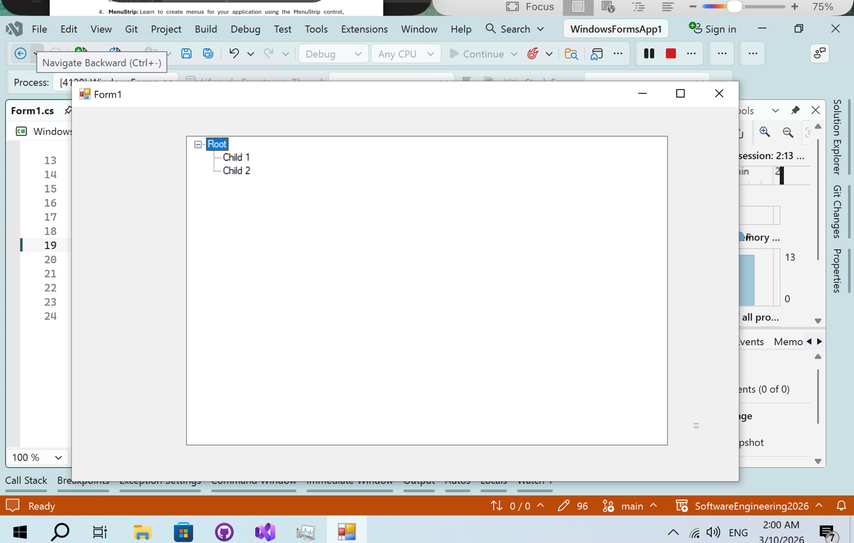
12
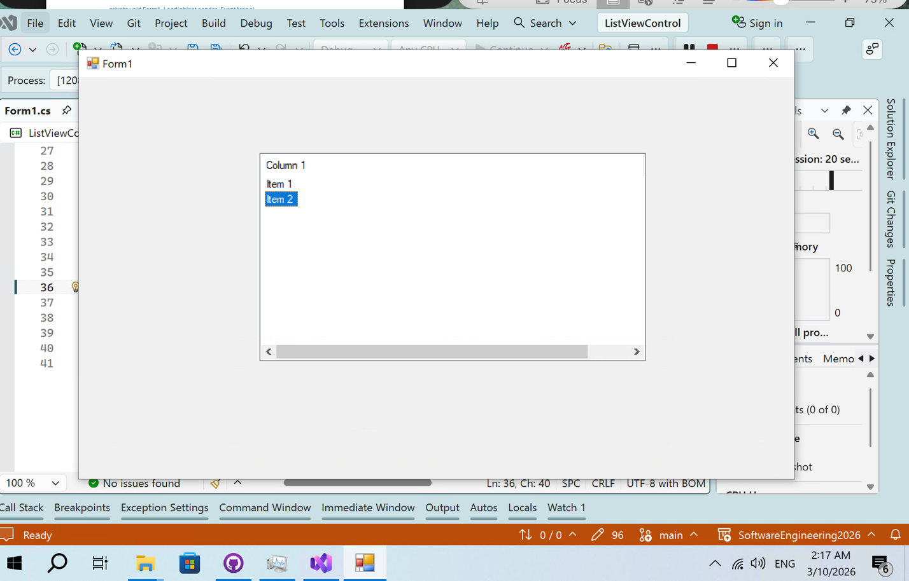
13

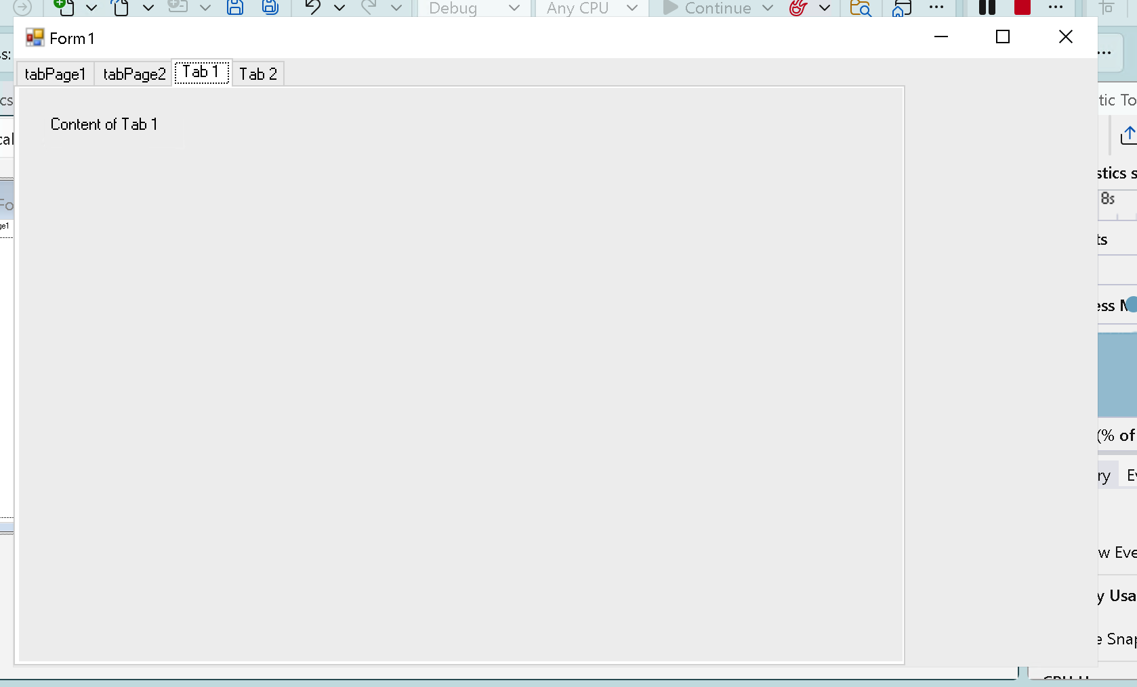
14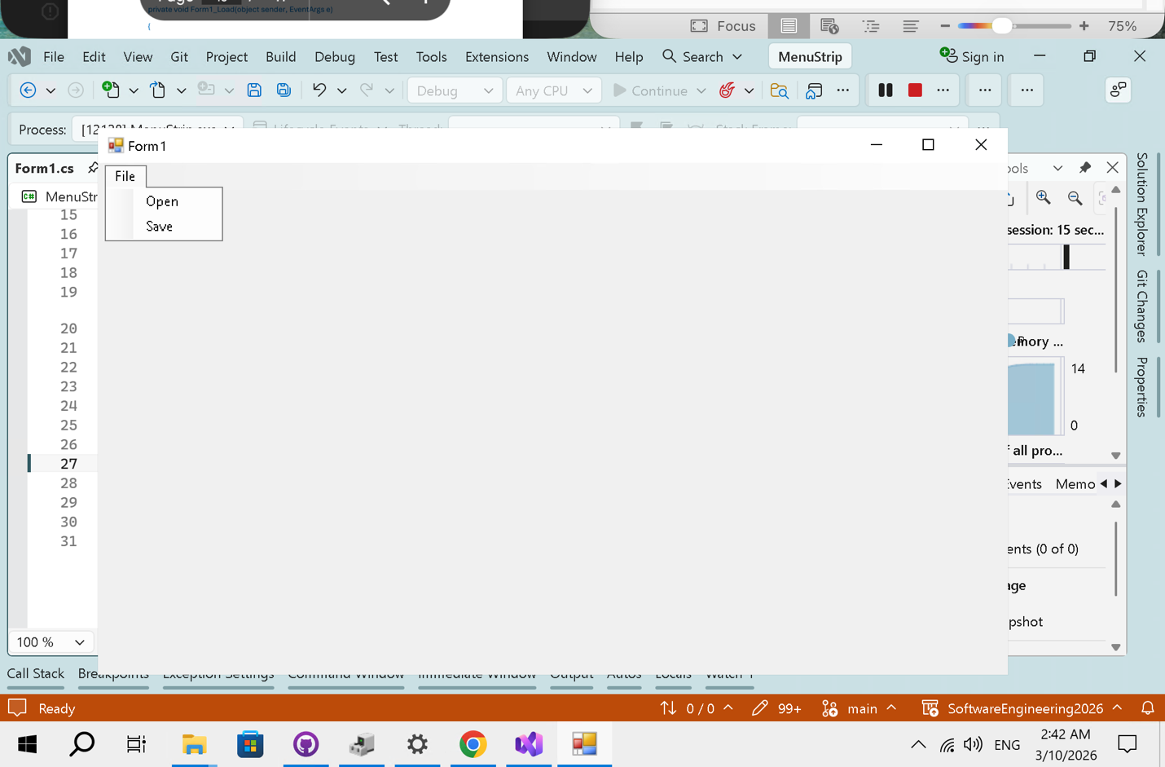
15
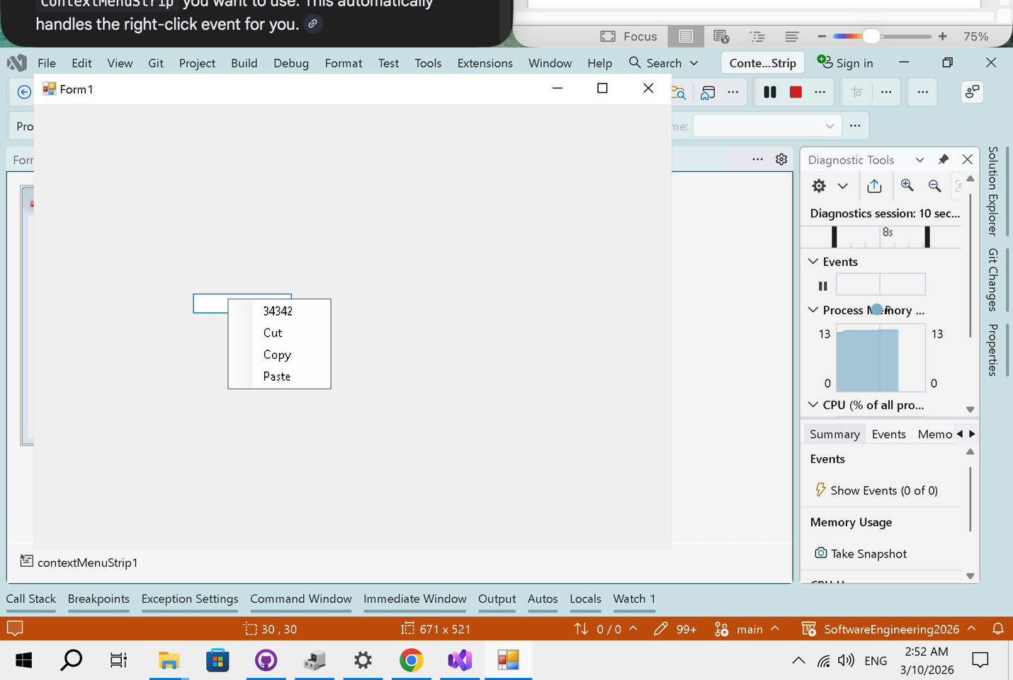
16
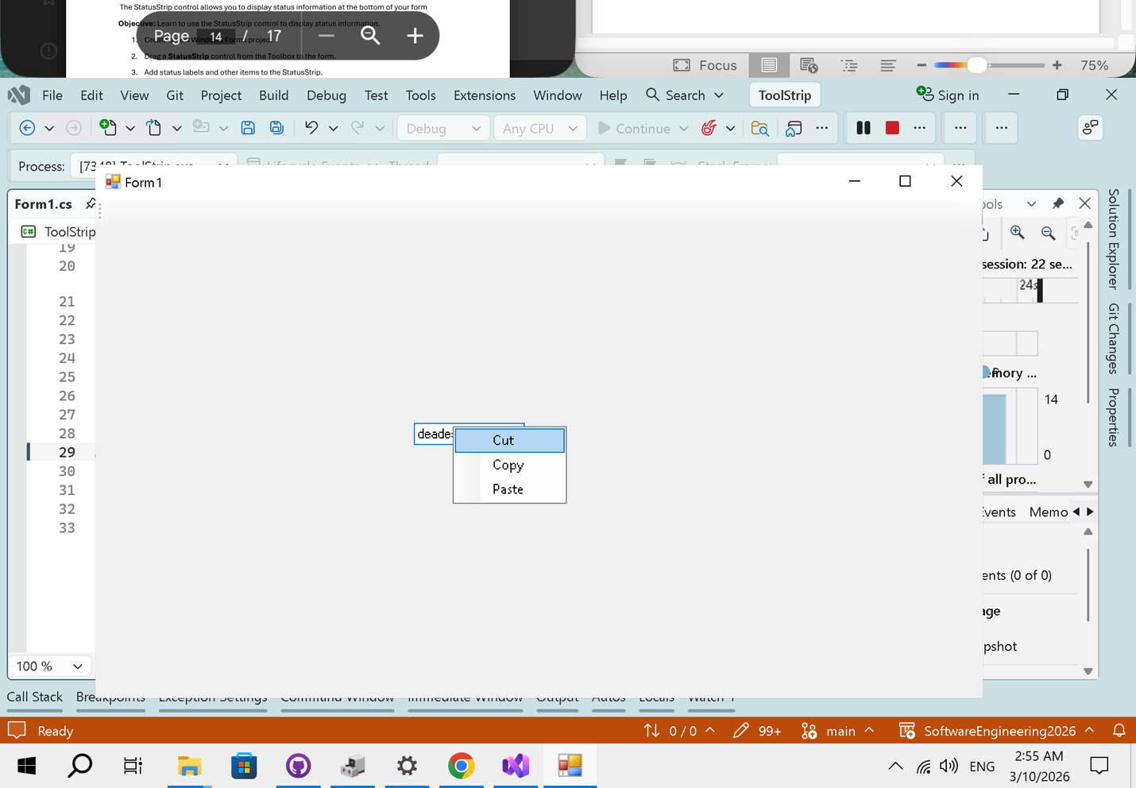

17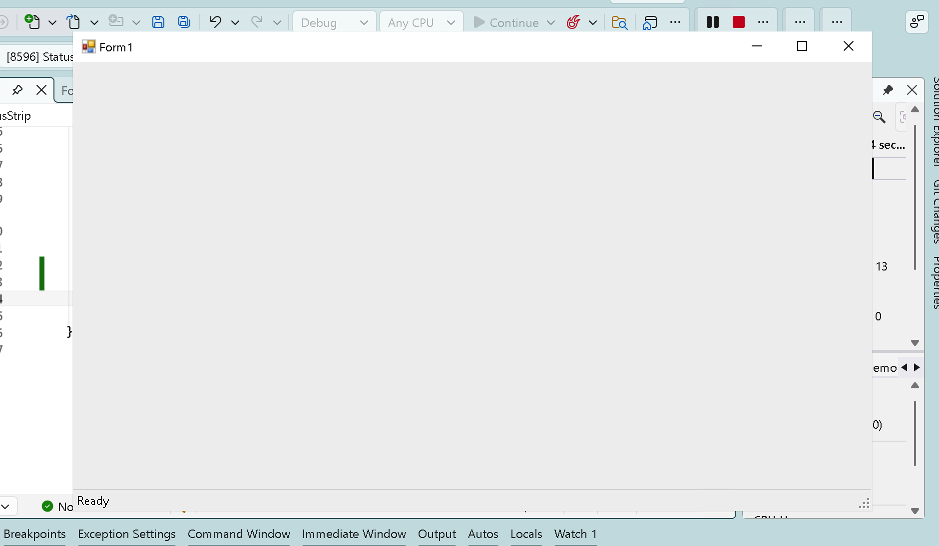
18

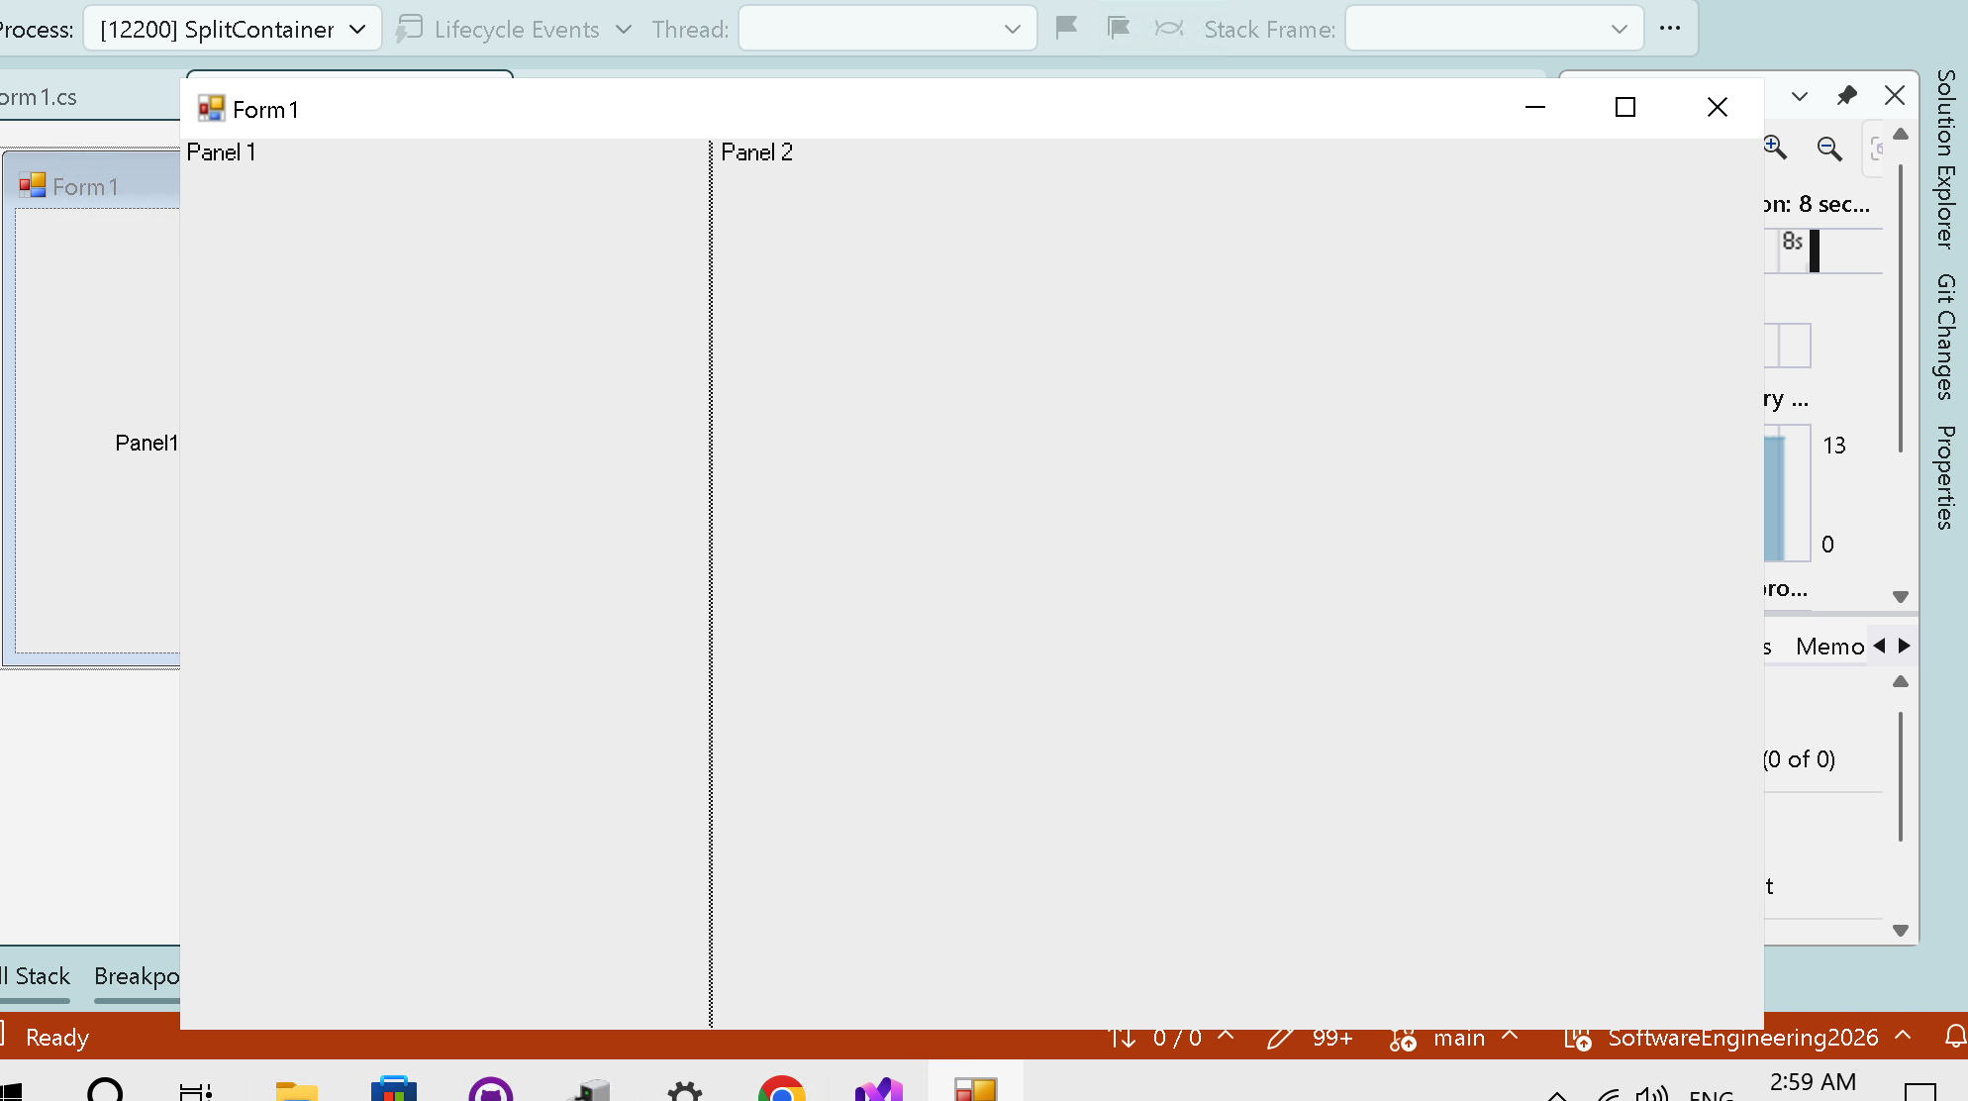
19
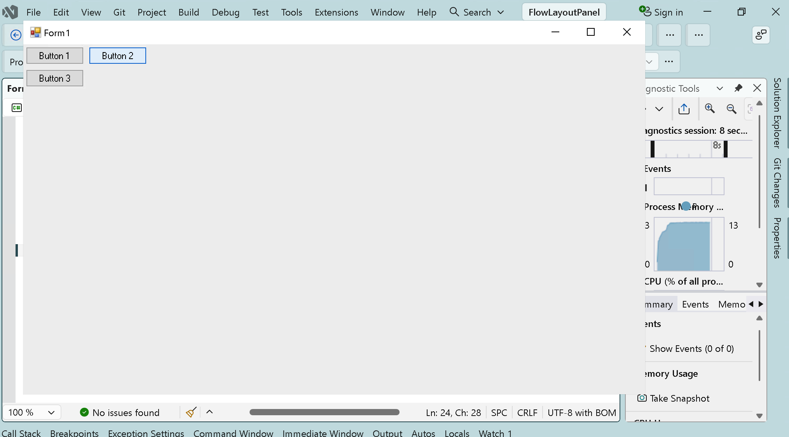
20
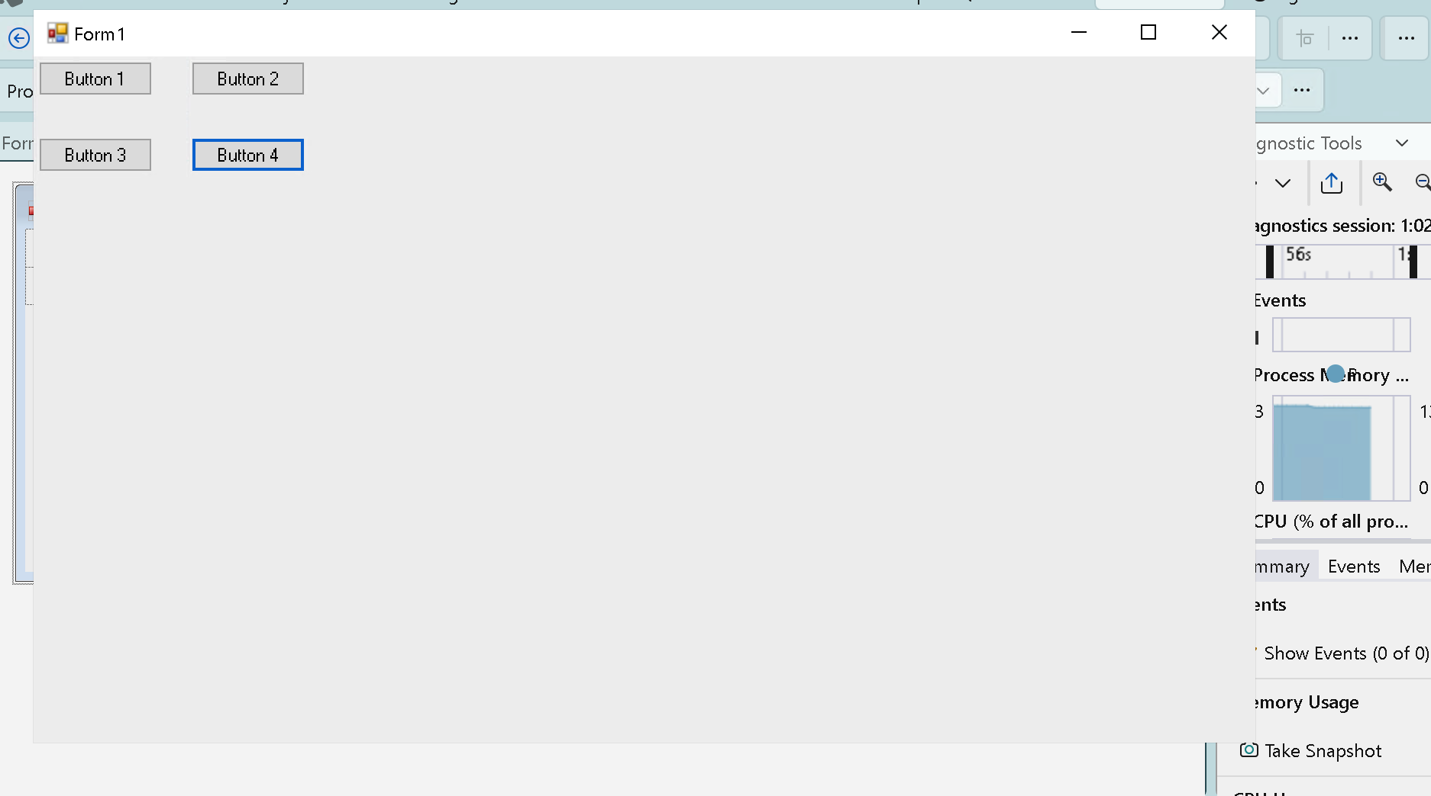
Developed by HuynhNhatHuy

